Investigating patterns assessment
Angles in Polygons

You will be assessed using these criterions:
Criterion B – Investigating patterns
Criterion C- Communication in mathematics
In previous work you saw that the sum of angles in a triangle is equal to 180° and the sum of the angles in a quadrilateral are 360°.
In this investigation you investigate the angle sums and the interior angles of regular polygons.
- A regular polygon is defined as a polygon in which all sides are equal and all interior angles are equal.
- A square is an example of a regular polygon, all sides are equal and angles are 90°
Directions:
- For each of the polygons shown in the table provided, chose one vertex and draw as many diagonals as possible to the other vertexes.

- Complete each column of the table by making observations and doing any necessary calculations

- What is the relationship between the number of sides of a polygon and the number of triangles formed from the diagonals?

- Describe any other patterns or relationships you see in the table

- Can you predict the angle sum of an icosagon (20 sides)? Explain your reasoning using your table. What about a polygon with 100 sides? Explain!

- What would be the interior angles of an icosagon (20 sides)? What about the interior angles of a polygon with 100 sides?

- Can you write a rule that will give the sum of the angles in any regular polygon? Define your variables when writing a rule. Can you explain why your rule works?

- Can you write a rule that will give the interior angles of any regular polygon? Define your variables when writing a rule. Can you explain why your rule works

Polygon | Name of Polygon | Number of sides | Number of Triangles formed from diagonals | Sum of interior angles | Measure of each interior angle
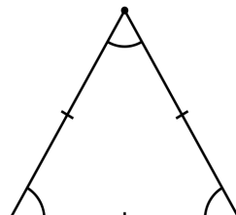 | Triangle
 | Square
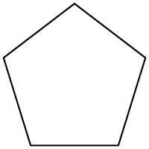 | Regular Pentagon
 | Regular  Hexagon
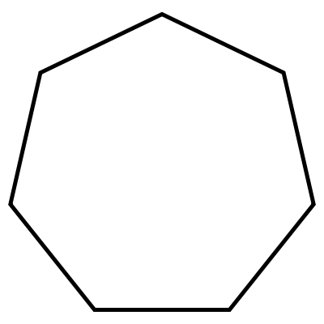 | Regular heptagon
 | Regular Octagon
 | Regular decagon

Task Title
Angles in polygons
Criterion B: Investigating patterns

Achievement level | Descriptor | Clarifications
1–2 | The student applies, with some guidance, mathematical problem-solving techniques to recognize simple patterns. | - You have completed the table for each of the polygons with guidance from the teacher  - You have recognized simple patterns from your table with guidance from the teacher
3–4 | The student selects and applies mathematical problem-solving techniques to recognize patterns, and suggests relationships or general rules. | - You have completed the table for each of the polygons correctly  - You have suggested at least one relationship/or rule from the table but you have not tested your rule or made any predictions from you observations  - You have made some type of prediction based on the patterns you observed
5–6 | The student selects and applies mathematical problem-solving techniques to recognize patterns, describes them as relationships or general rules, arrives at a single result, or set of results, and makes predictions consistent with findings. | - You have completed the table for each of the polygons correctly  - You have suggested more than one relationship/or rule from the table and described these patterns as relationships or rules  - You have made an accurate predictions consistent with your findings for the sum of interior angles for a 20 sided polygon  - You have made an accurate prediction consistent with your findings for the measure of the interior angles for a 20 sided polygon
7–8 | The student selects and applies mathematical problem-solving techniques to recognize patterns, describes them as relationships or general rules, produces results and makes predictions, based on their findings, which are explained using logical arguments. | - You have completed the table for each of the polygons correctly  - You have suggested several relationship/or rule from the table and described these patterns as relationships or rules  - You have made an accurate prediction consistent with your findings for the measure of the interior angles for a 20 sided polygon  - You have made a logical argument describing why your rule works for the sum of the angles for any regular polygons  - You have made a logical argument describing why your rule works for the interior angles for any regular polygons

Task Title
Angles in polygons
Criterion C: Communication in mathematics

Achievement level | Descriptor | Clarifications
1–2 | The student shows basic use of mathematical language and/or forms of mathematical representation. The lines of reasoning are difficult to follow. | - You have used basic language and when trying to describe your observations from the table.  - Your lines of reasoning are difficult to follow and little attempt is made to use vocabulary related to geometry
3–4 | The student shows sufficient use of mathematical language and forms of mathematical representation. The lines of reasoning are clear though not always logical or complete. | - You have used sufficient vocabulary related to geometry when describe patterns you have observed from the table  - You have described at least one relationship using words but the lines of reasoning are not always logical or complete  - You have made an attempt to write a rule using symbols and/or variables but the rule is not logical and/or complete
5–6 | The student shows good use of mathematical language and forms of mathematical representation. The lines of reasoning are concise, logical and complete. The student moves between different forms of representation with some success. | - You have used a variety of vocabulary related to geometry  - You lines of reasoning are concise logical and complete  - You have written rules using variables  - You have defined the variables that you have used

